Week 12 Lecture 2

Previous Lecture
- Sorting Algorithms (1)

Today’s Lecture
- Sorting Algorithms (2)
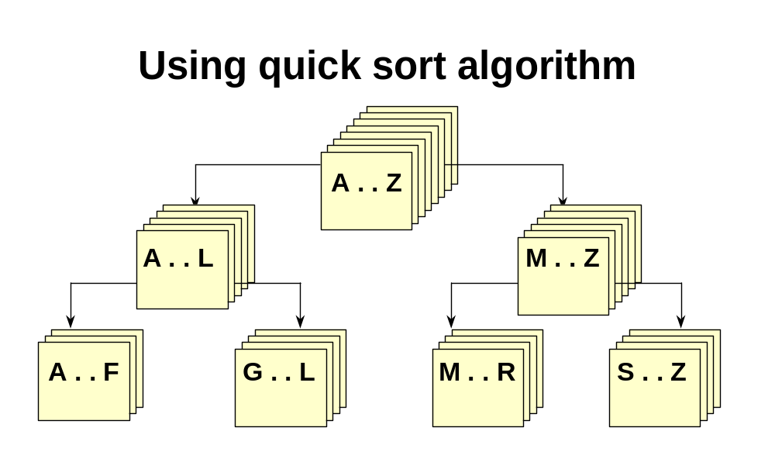

Quick Sort

If there is more than one item in values[first]..values[last]
- Select splitVal
- Split the array so that
- values[first]..values[splitPoint-1] <= splitVal
- values[splitPoint] = splitVal
- values[splitPoint+1]..values[last] > splitVal
- QuickSort the left half
- QuickSort the right half
// Recursive quick sort algorithm

template <class ItemType >
void QuickSort ( ItemType values[ ] , int first , int last )

// Pre: first <= last
// Post: Sorts array values[ first . . last ] into ascending order
{
if ( first < last ) // general case

{ int splitPoint ;

Split ( values, first, last, splitPoint ) ;

// values [ first ] . . values[splitPoint - 1 ] <= splitVal
// values [ splitPoint ] = splitVal
// values [ splitPoint + 1 ] . . values[ last ] > splitVal

QuickSort( values, first, splitPoint - 1 ) ;
QuickSort( values, splitPoint + 1, last );
}

} ;
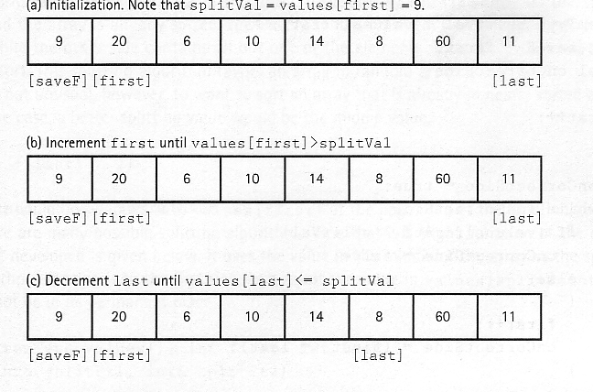
Split Process
Split Process
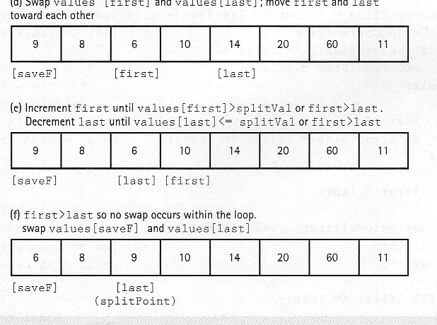
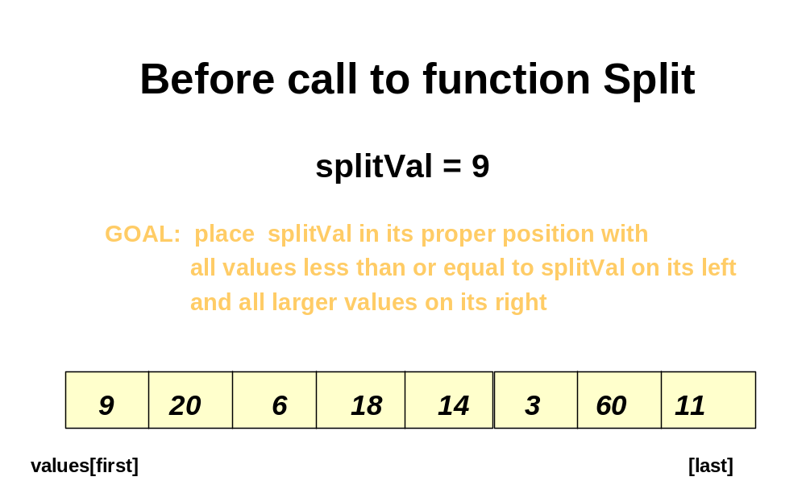

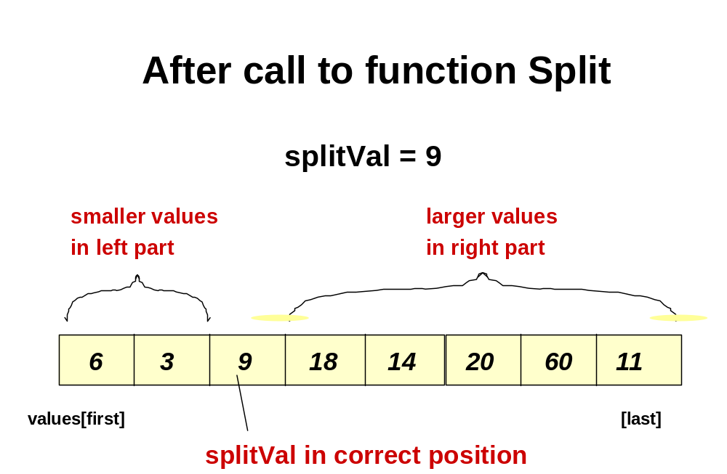
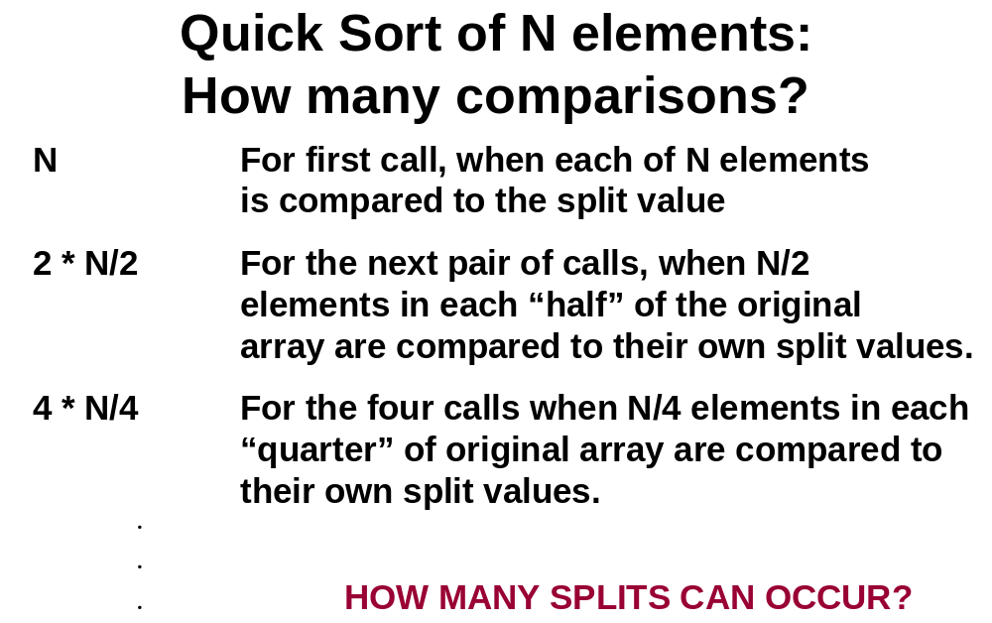

Quick Sort of N elements:
How many splits can occur?

It depends on the order of the original array elements!
If each split divides the subarray approximately in half,
there will be only log₂N splits, and QuickSort is O(N*log₂N).

But, if the original array was sorted to begin with, the
recursive calls will split up the array into parts of
unequal length, with one part empty, and the
other part containing all the rest of the array except for split value itself. In this case, there can be as many as N-1 splits, and QuickSort is O(N²).
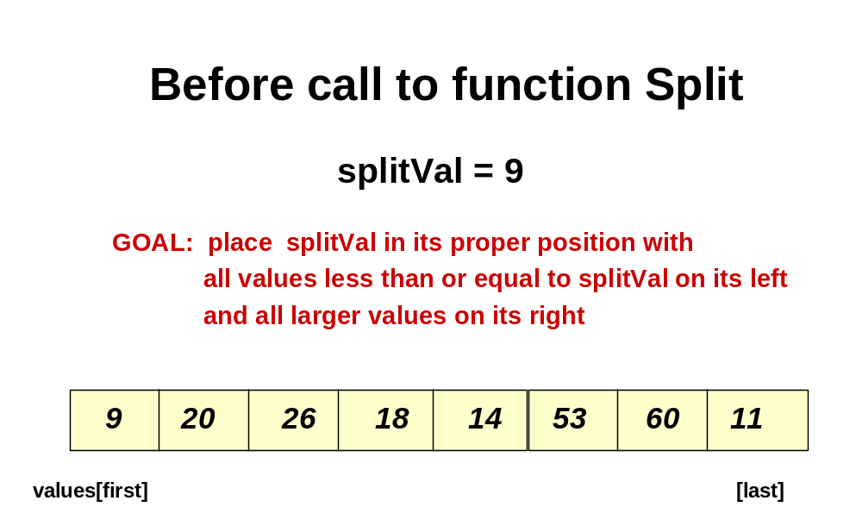
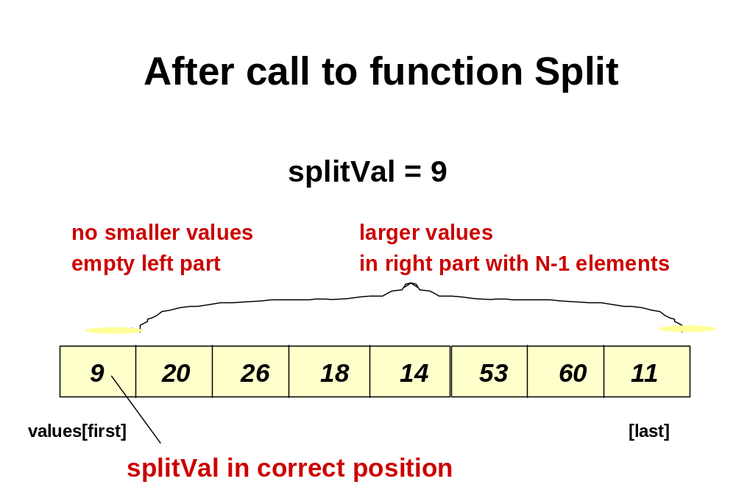
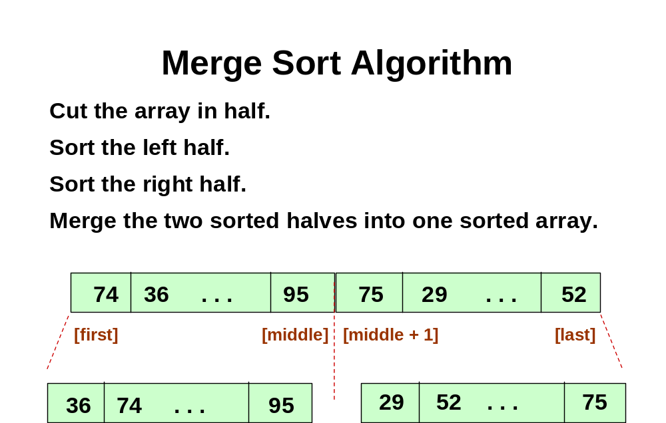
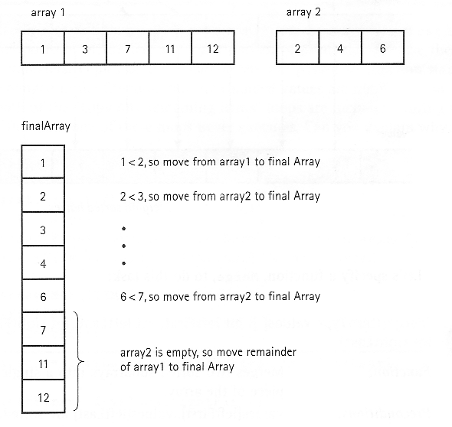

Merge Process
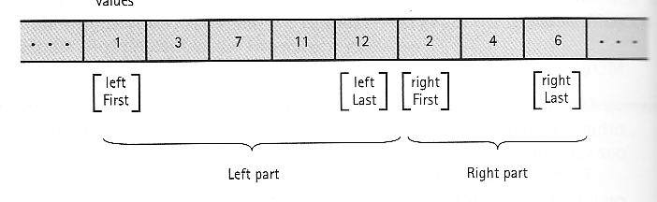
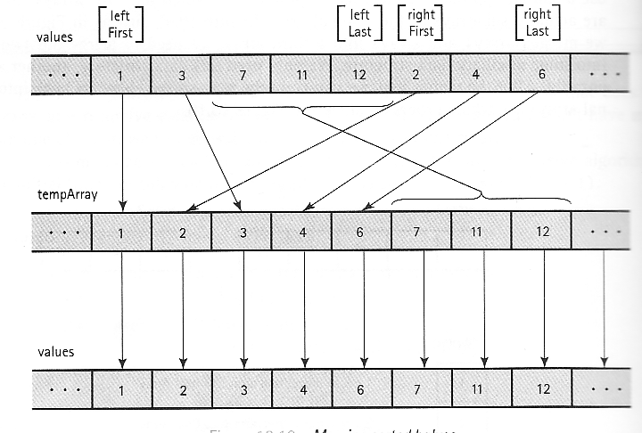
// Recursive merge sort algorithm

template <class ItemType >
void MergeSort ( ItemType values[ ] , int first , int last )

// Pre: first <= last
// Post: Array values[ first . . last ] sorted into ascending order.
{
if ( first < last ) // general case

{ int middle = ( first + last ) / 2 ;

MergeSort ( values, first, middle ) ;

MergeSort( values, middle + 1, last ) ;

// now merge two subarrays
// values [ first . . . middle ] with
// values [ middle + 1, . . . last ].

Merge( values, first, middle, middle + 1, last ) ;
}
}

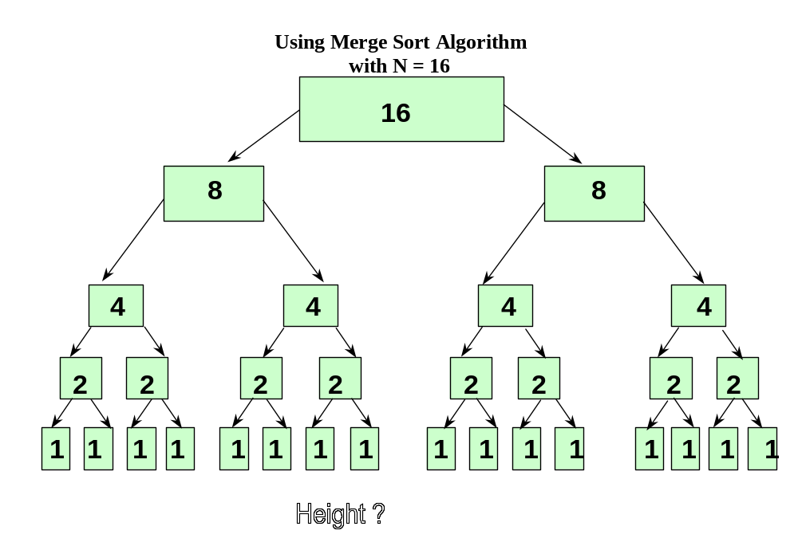
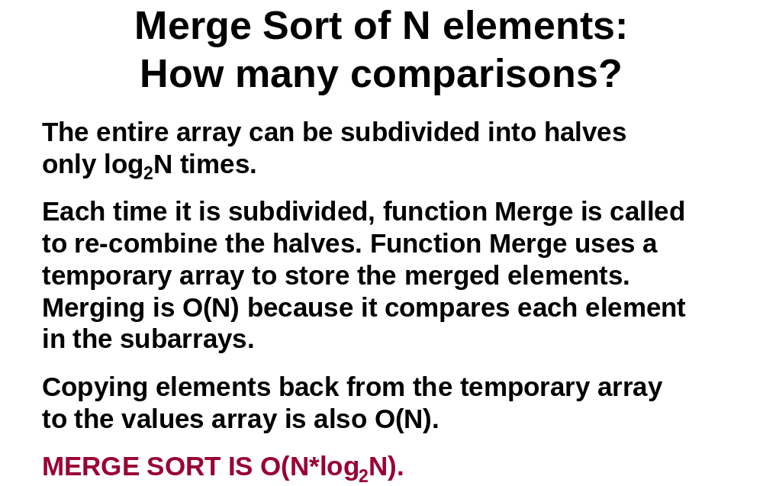

Function BinarySearch( )

- BinarySearch takes sorted array info, and two subscripts, fromLoc and toLoc, and item as arguments. It returns false if item is not found in the elements info[fromLoc…toLoc]. Otherwise, it returns true.

- BinarySearch is O(log₂N).

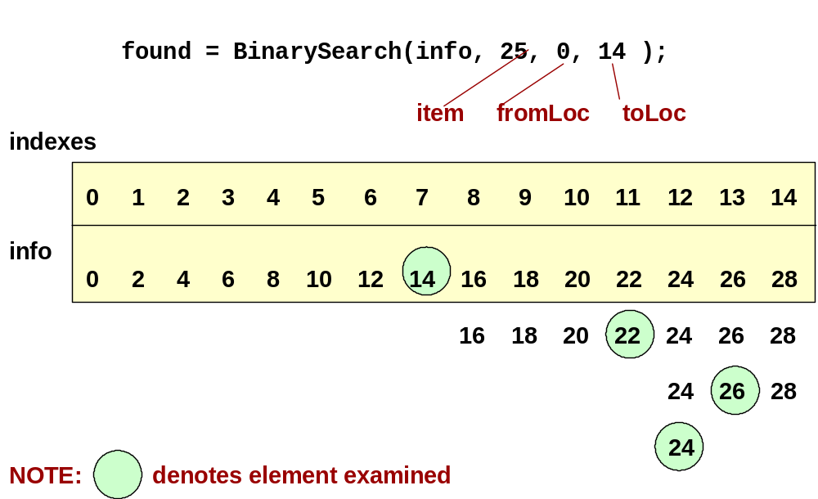
template<class ItemType>
bool BinarySearch ( ItemType info[ ] , ItemType item ,
int fromLoc , int toLoc )
// Pre: info [ fromLoc . . toLoc ] sorted in ascending order
// Post: Function value = ( item in info [ fromLoc . . toLoc] )

{ int mid ;
if ( fromLoc > toLoc ) // base case -- not found
return false ;
else {
mid = ( fromLoc + toLoc ) / 2 ;

if ( info [ mid ] == item ) // base case-- found at mid

return true ;

else if ( item < info [ mid ] ) // search lower half
return BinarySearch ( info, item, fromLoc, mid-1 ) ;
else // search upper half
return BinarySearch( info, item, mid + 1, toLoc ) ;
}

}

Search

Linear search O(N)

Unsorted lists

Sorted lists

Binary search O(log₂N)

Sorted lists

How about O(1) ?

Simple Example

100 employees in a company

Why do not use an array [0..99]

Employee ID may be five-digit

Array[0..100000] to hold 100 people

A better way?

Hashing

- is a means used to order and access elements in a list quickly -- the goal is O(1) time -- by using a function of the key value to identify its location in the list.

- The function of the key value is called a hash function.
FOR EXAMPLE . . .

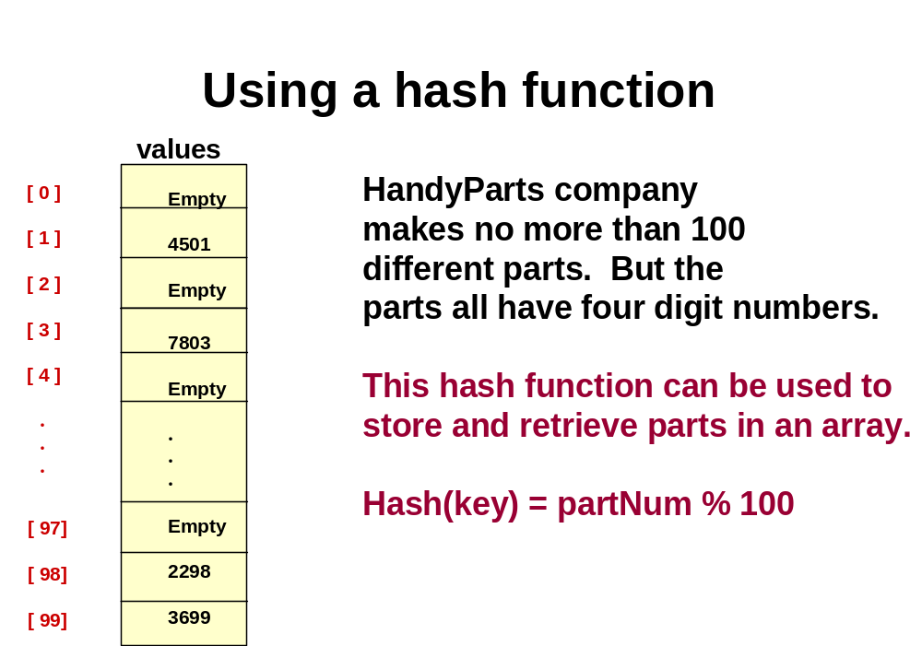
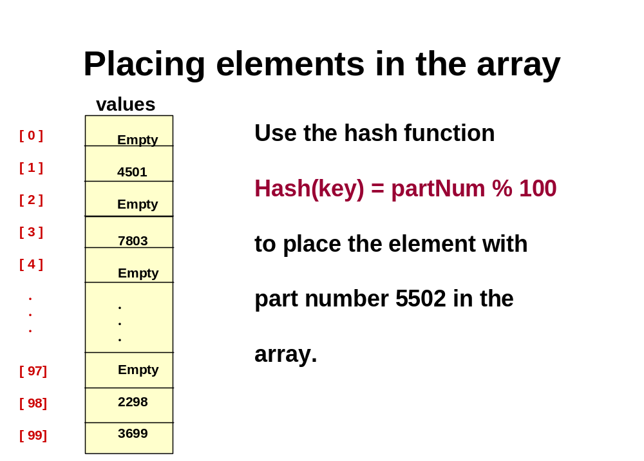
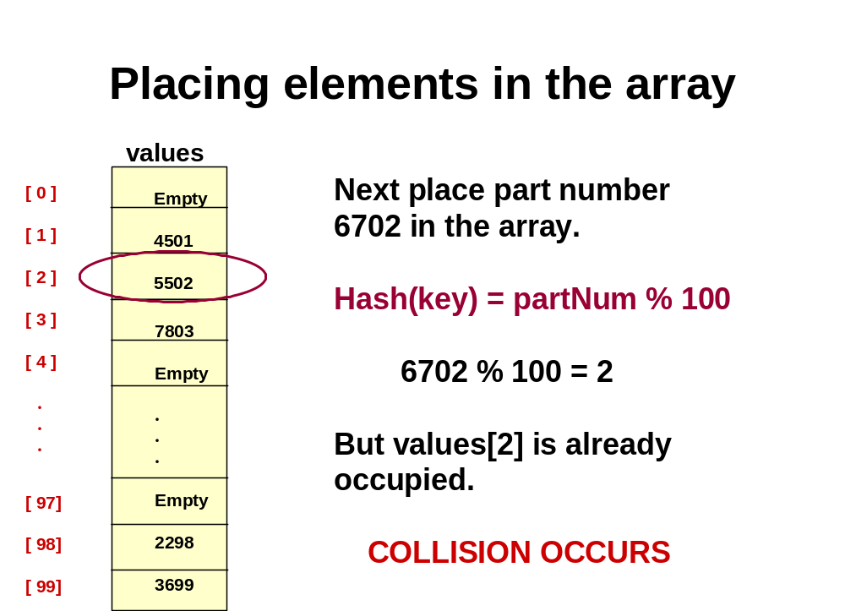
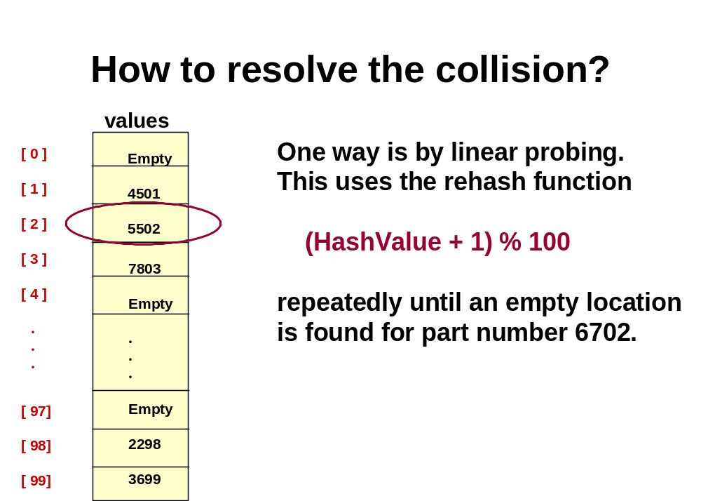
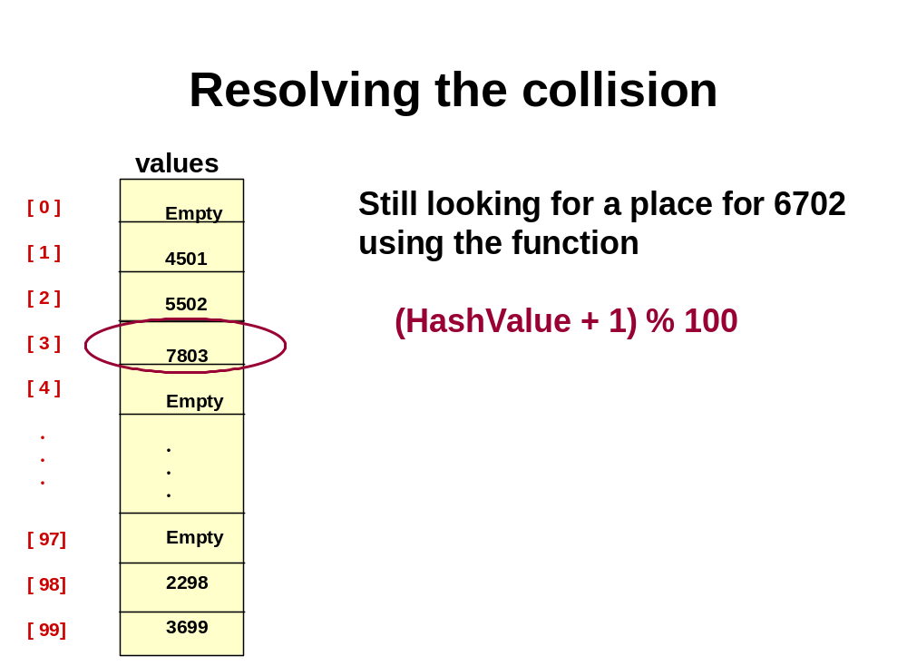
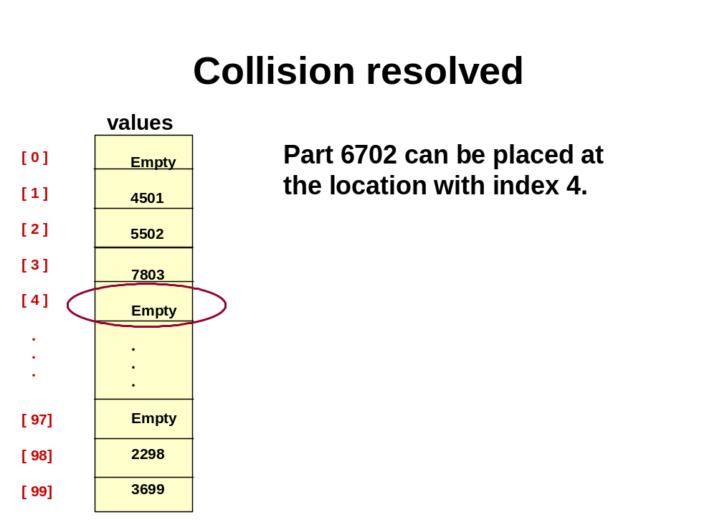
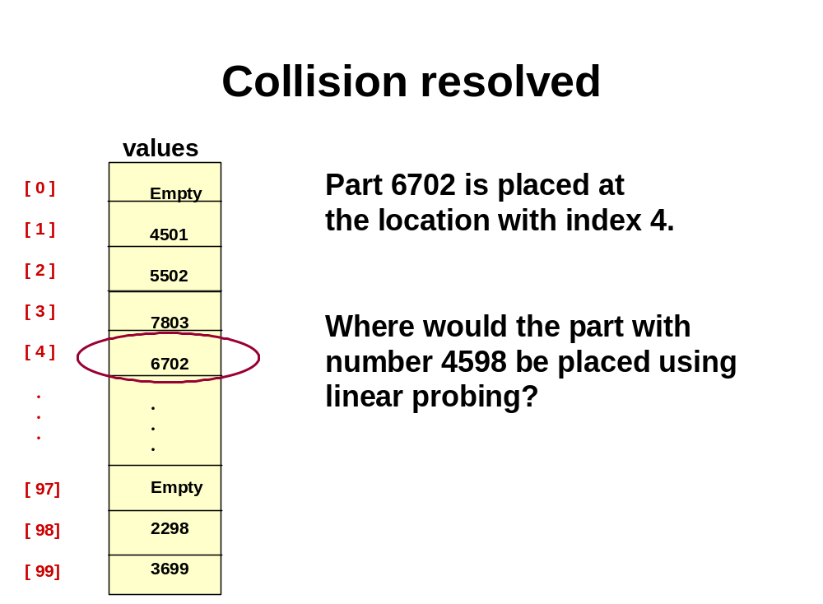

Clustering

The tendency of elements to become unevenly distributed in the hash table, with many elements clustering around a single hash location.

Solutions to Clustering

Linear probing with a constant

(HashValue + constant) % array_size

quadratic probing

(HashValue + I²) % array_size

I is number of times that the rehash func has been used

Random probing

Uses a pseudo-random number generator to determine the increment to HashValue

Bucket or Chain

A bucket or a linked list of elements that share the same hash location

Bucket
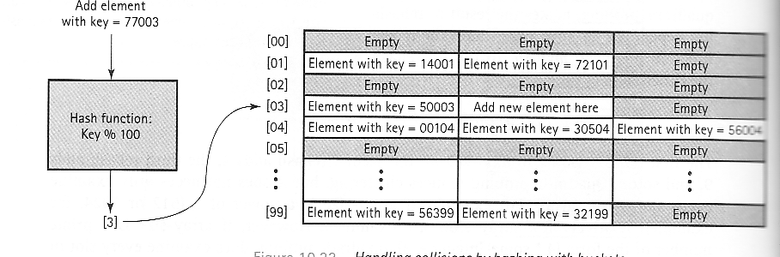

Chain
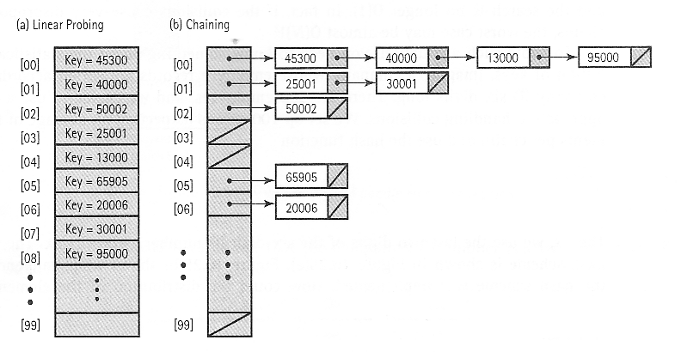

Time Complexity of Hashing Search

Best case O(1)

Worst case O(N)

Today’s Lecture

- Sorting Algorithms(2)

Next Lecture

- File Processing

